**Prerequisites**

* Create an Azure DevOps organization. Make sure you are an administrator of the Azure DevOps project.
  + For this demo, the following project exists within the AT&T environment.
    - [**https://dev.azure.com/poc2pattern/POCtoPattern**](https://dev.azure.com/poc2pattern/POCtoPattern)
* Create a shared image gallery
* First two build pipelines executed to create a base image and customize it with tomcat.

**Create a Service Connection**

1. In Azure DevOps, open the **Service connections** page from the [project settings page](https://docs.microsoft.com/en-us/azure/devops/project/navigation/go-to-service-page?view=azure-devops#open-project-settings). In TFS, open the **Services** page from the "settings" icon in the top menu bar.
2. Choose **+ New service connection** and select the type of service connection you need.
3. Fill in the parameters for the service connection. The list of parameters differs for each type of service connection - see the [following list](https://docs.microsoft.com/en-us/azure/devops/pipelines/library/service-endpoints?view=azure-devops#ep-types). For example, this is the default **Azure Resource Manager** connection dialog. Choose Service Principal Authentication.

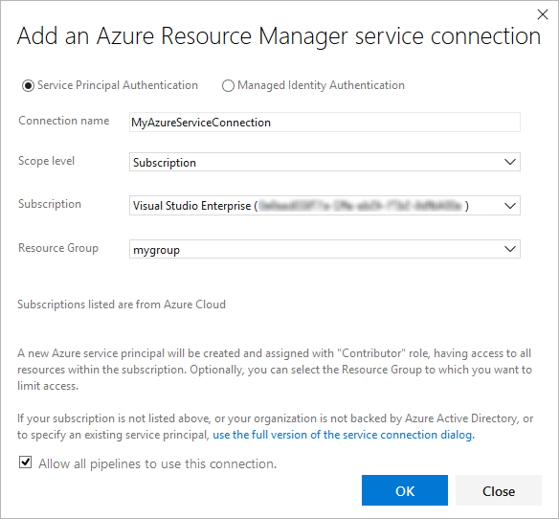

1. Decide if you want the service connection to be accessible for any pipeline by setting the **Allow all pipelines to use this connection** option. This option allows pipelines defined in YAML, which are not automatically authorized for service connections, to use this service connection. See [Use a service connection](https://docs.microsoft.com/en-us/azure/devops/pipelines/library/service-endpoints?view=azure-devops#use-connection).
2. Choose **OK** to create the connection.

For more information about Azure Resource Manager service connections, see [Connect to Microsoft Azure](https://docs.microsoft.com/en-us/azure/devops/pipelines/library/connect-to-azure?view=azure-devops). You can also create your own [custom service connections](https://docs.microsoft.com/en-us/azure/devops/extend/develop/service-endpoints?view=azure-devops).

* Create the KeyVault following the documentation under the following link.
  + <https://dev.azure.com/poc2pattern/_git/POCtoPattern?path=%2FKeyVaultDiskEncryption%2Freadme.rtf&version=GBmaster>

**Initialize the repository**

* Go to **Azure Repos**. (The **Code** hub in the previous navigation)
* For this demo, the follow Repo exists within the AT&T environment.
  + [**https://dev.azure.com/poc2pattern/POCtoPattern/_git/POCtoPattern?path=%2F&version=GBmaster**](https://dev.azure.com/poc2pattern/POCtoPattern/_git/POCtoPattern?path=%2F&version=GBmaster)

**Create a Release Pipeline**

Create a Release pipeline that uses the customized Tomcat image from the Shared Image Gallery to deploy a scale set.

1. Select **Azure Pipelines**.
2. Select the Releases button under Pipelines and choose New Pipeline.
3. Make sure that the **source**, **project**, **repository**, and default **branch** match the location where the scripts are located.
4. Start with an **Empty job**.
5. On the left side, select **Pipeline** and specify whatever **Name** you want to use. For the **Agent pool**, select **Hosted VS2017**.
6. On the left side, select the plus sign **( + )** to add a task to **Job 1**. On the right side, select the **Utility** category, select the **Replace tokens** task from the list, and then choose **Add**.
7. On the left side, select your new **Replace tokens** task.
8. Fill out the configuration information as shown below.

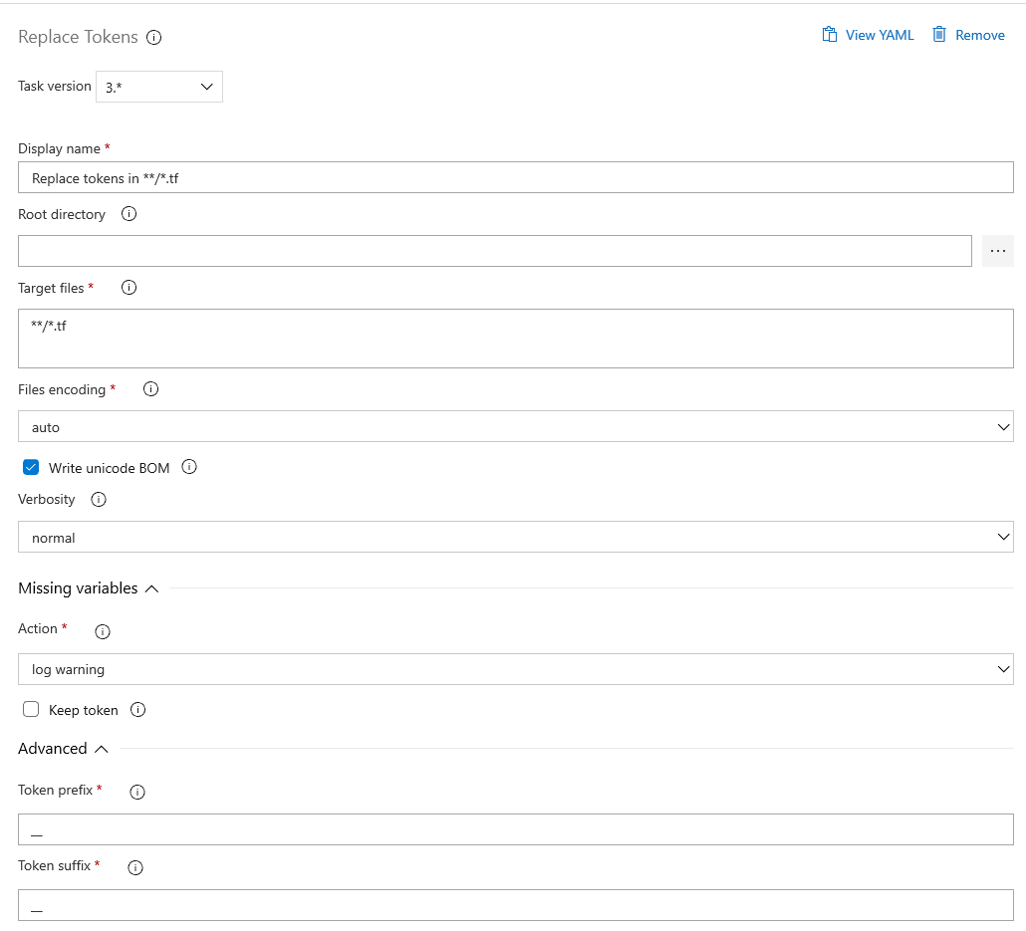

1. Select **Save**, and then select **Save**.
2. On the left side, select the plus sign **( + )** to add a task to **Job 1**. On the right side, select the **Utility** category, select the **Run Terraform** task from the list, and then choose **Add**.
3. On the left side, select your new **Run Terraform** task. Fill out the following information for Terraform init. Source repo folder and Service Connection.

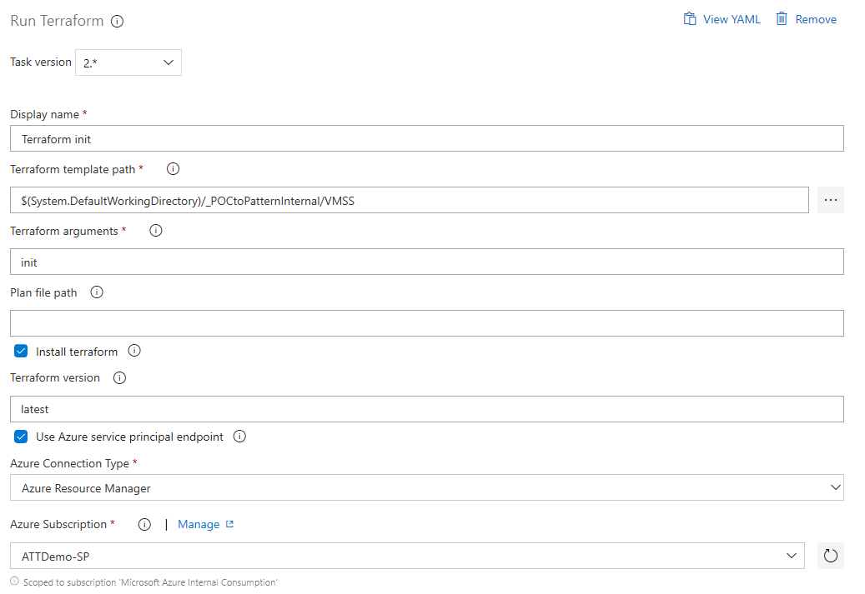

1. Select **Save**, and then select **Save**.
2. On the left side, select the plus sign **( + )** to add a task to **Job 1**. On the right side, select the **Utility** category, select the **Run Terraform** task from the list, and then choose **Add**.
3. On the left side, select your new **Run Terraform** task. Fill out the following information for Terraform plan.

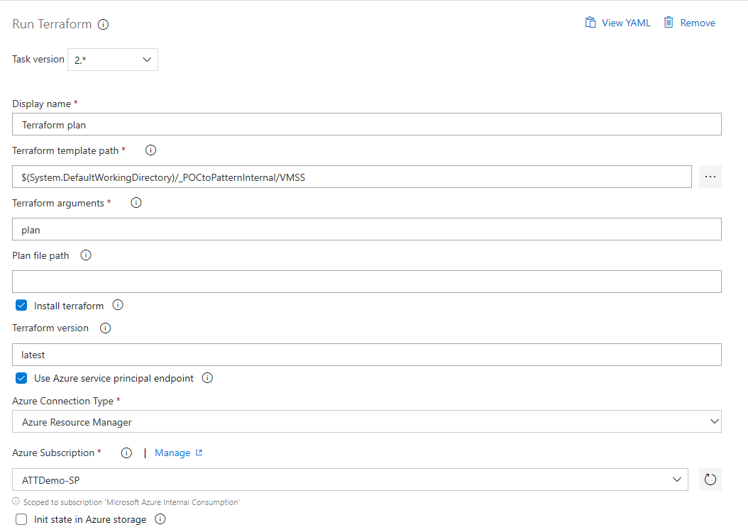

23. Select **Save**, and then select **Save**.

24. On the left side, select the plus sign **( + )** to add a task to **Job 1**. On the right side, select the **Utility** category, select the **Run Terraform** task from the list, and then choose **Add**.

25. On the left side, select your new **Run Terraform** task. Fill out the following information for Terraform apply.

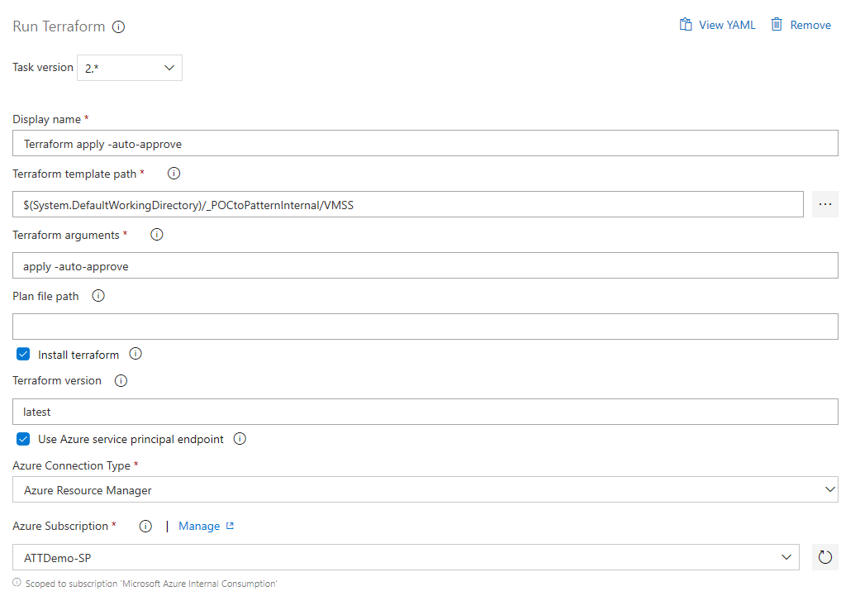

1. Select **Save**, and then select **Save**.
2. Fill out all the Pipeline Variables below.

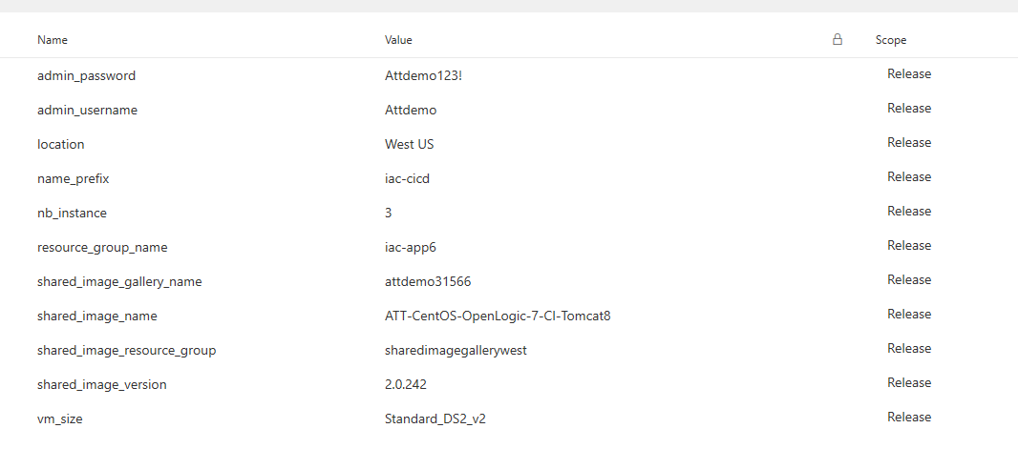

1. Queue the build pipeline by clicking the Queue button
2. The output is a managed image in a resource group and a shared image gallery version in the location specified in the environment variables.

A build pipeline is the entity through which you define your automated build pipeline. In the build pipeline, you compose a set of tasks, each of which perform a step in your build. The task catalog provides a rich set of tasks for you to get started. You can also add PowerShell or shell scripts to your build pipeline.